Here are **10 reusable, audit-ready frameworks** for the **Cloud AI Platform CoE** under the Microsoft Frontier Distribution Designation. These are designed as mature, production-grade assets for your centralized knowledge repository—structured for easy reuse by resellers, with clear components, architecture patterns, best practices, security/governance notes, and direct ties to official Microsoft reference architectures (e.g., Azure Architecture Center, AI Foundry, Well-Architected Framework for AI).

Each framework includes:
- **Framework ID** and **Version** (for governance tracking)
- **Overview** and **Business Value**
- **Key Components** (Azure services)
- **Architecture Summary** (with diagram placeholders or references)
- **Implementation Guidance & Best Practices**
- **Security, Compliance & Governance**
- **References** (official Microsoft links for credibility)

These are based on current Azure AI patterns as of February 2026, including Azure AI Foundry, OpenAI integrations, and GenAI design patterns. Upload to your repo with version history, ARM/Bicep templates, and sample code links for full audit demo readiness.

### 1. Retrieval-Augmented Generation (RAG) Framework
**Framework ID:** COE-CAI-FW-001-RAG
**Version:** 2.0 | **Last Updated:** Feb 2026

**Overview & Value:** Standard pattern for grounding LLMs in enterprise data to minimize hallucinations and enable accurate, source-traceable responses. Accelerates partner delivery of chatbots, knowledge assistants, and Q&A tools.

**Key Components:** Azure OpenAI (GPT models), Azure AI Search (vector/hybrid), Azure Blob/ADLS, Azure AI Document Intelligence, Azure Functions/Logic Apps.

**Architecture Summary:** User query → Orchestrator → Hybrid retrieval (vector + keyword + semantic) → Prompt augmentation → LLM generation → Response with citations. Ingestion: Document chunking/embedding → Index creation.

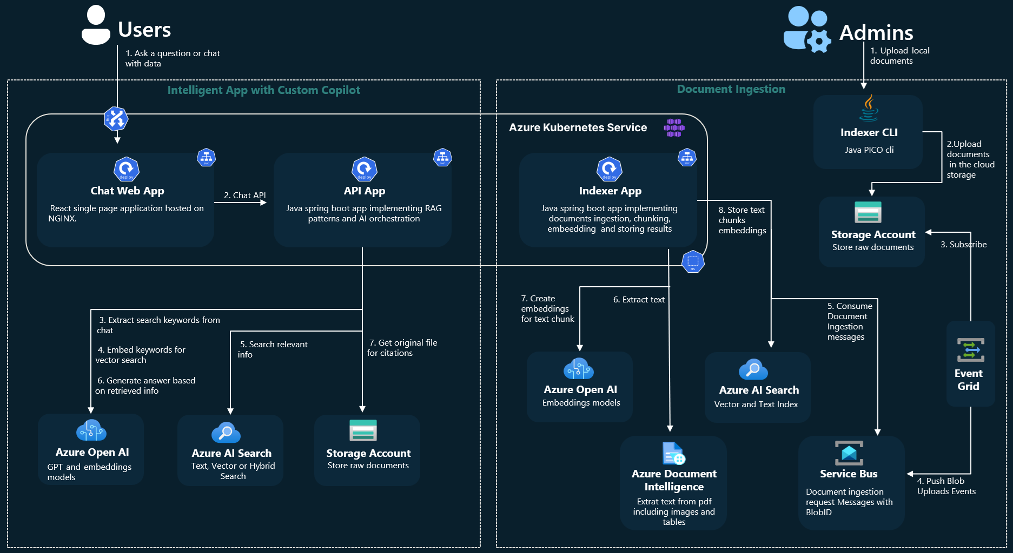
**Best Practices:** Chunk size 500-1000 tokens, hybrid search weighting, semantic reranker, evaluation with RAG metrics (groundedness >85%).

**Security & Governance:** Private endpoints, RBAC, content filters, audit logging to Log Analytics.

**References:** learn.microsoft.com/en-us/azure/architecture/ai-ml/guide/rag/rag-solution-design-and-evaluation-guide; Azure AI Search RAG overview.

### 2. Azure AI Foundry Agent Framework
**Framework ID:** COE-CAI-FW-002-FOUNDRY-AGENT
**Version:** 1.1

**Overview & Value:** Framework for building, deploying, and scaling single/multi-agent systems using Azure AI Foundry Agent Service for complex, autonomous workflows.

**Key Components:** Azure AI Foundry (Agents, Actions, Knowledge), Microsoft Agent Framework (Python/.NET SDK), Semantic Kernel, Azure OpenAI.

**Architecture Summary:** Hub/project → Agent definition (tools/knowledge) → Orchestration (selection/termination) → Execution loop → Output.

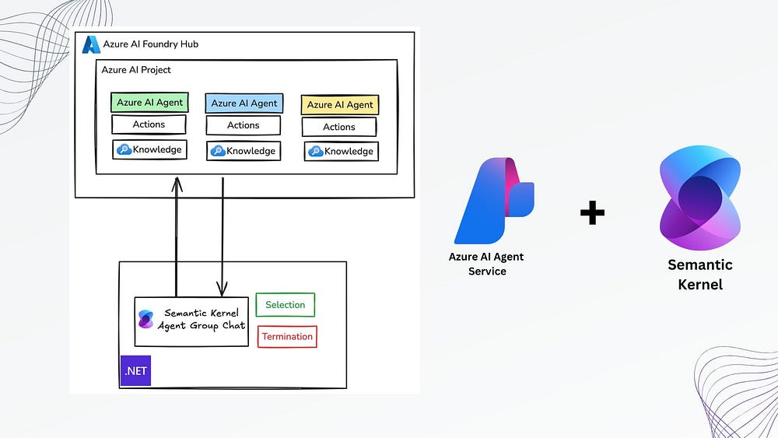

**Best Practices:** Persistent agents, action isolation, retry logic, agent types (e.g., reactive vs. proactive).

**Security & Governance:** Managed identities, private links, agent isolation, monitoring with Azure Monitor.

**References:** learn.microsoft.com/en-us/agent-framework; github.com/microsoft/agent-framework.

### 3. Multi-Agent Orchestration Framework
**Framework ID:** COE-CAI-FW-003-MULTI-AGENT
**Version:** 1.0

**Overview & Value:** Enables collaborative agents for advanced tasks (e.g., research + summarization + validation). Ideal for complex business automation.

**Key Components:** Azure AI Foundry Agents, Semantic Kernel, Azure Functions, Cosmos DB (state).

**Architecture Summary:** Supervisor agent → Delegate to specialized agents → Collaborative filtering/aggregation → Final response.
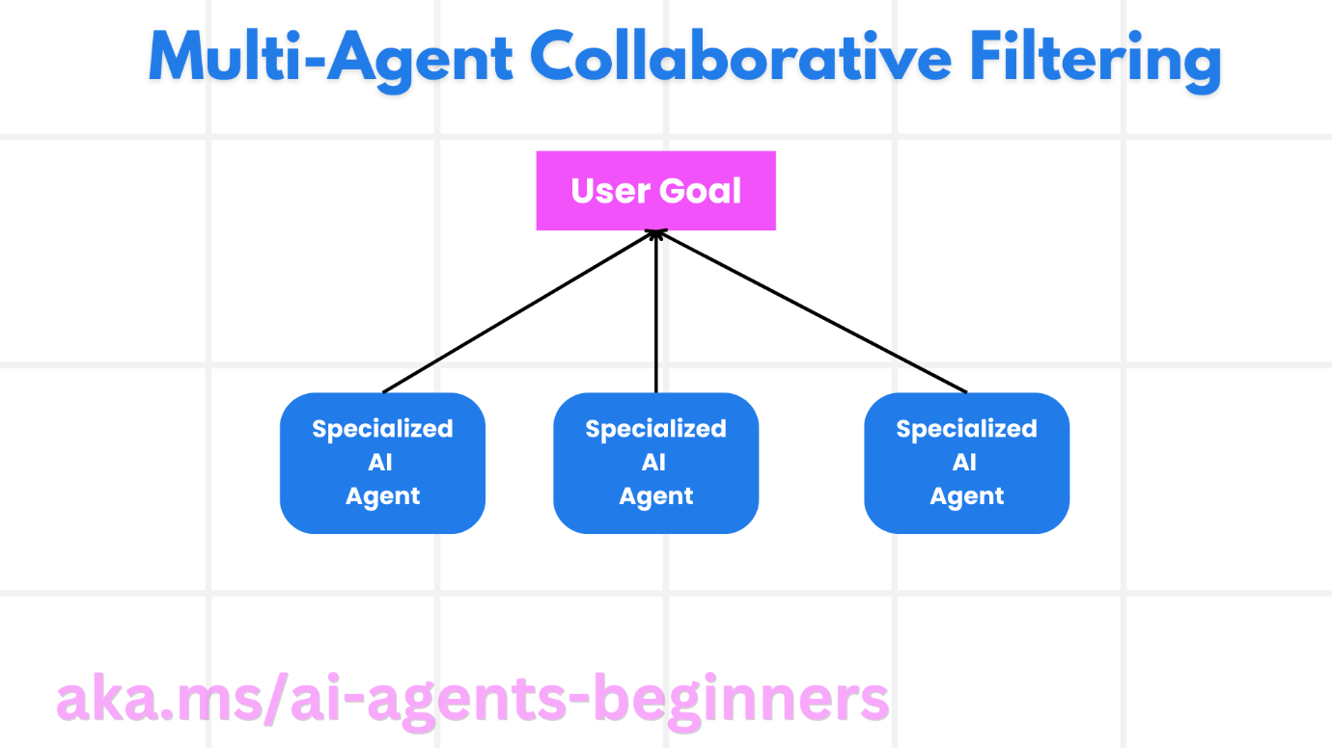

**Best Practices:** Hierarchical design, error handling, termination conditions, filtering patterns.

**Security & Governance:** Agent-level RBAC, data residency.

**References:** learn.microsoft.com/en-us/azure/databricks/generative-ai/guide/agent-system-design-patterns; microsoft.github.io/ai-agents-for-beginners.

### 4. Enterprise Chat Application Framework (Baseline Foundry Chat)
**Framework ID:** COE-CAI-FW-004-BASELINE-CHAT
**Version:** 1.0

**Overview & Value:** End-to-end chat architecture for grounded, enterprise-ready conversational AI.

**Key Components:** Azure OpenAI, Azure AI Foundry, Azure AI Search, App Service, Cosmos DB (memory).

**Architecture Summary:** UI → Gateway → Agent → Retrieval/generation → Memory persistence.

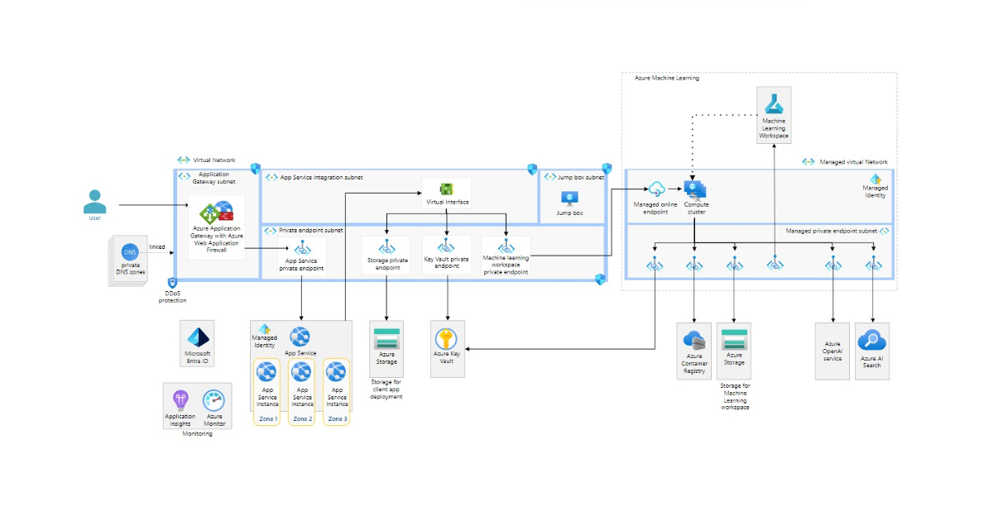

**Best Practices:** Zonal redundancy, multi-turn context, streaming responses.

**Security & Governance:** Private Link, WAF, content safety.

**References:** learn.microsoft.com/en-us/azure/architecture/ai-ml/architecture/baseline-microsoft-foundry-chat.

### 5. Azure AI Landing Zone Framework
**Framework ID:** COE-CAI-FW-005-LANDING-ZONE
**Version:** 1.0

**Overview & Value:** Hub-and-spoke model for secure, scalable AI deployments across tenants/regions.

**Key Components:** Azure Landing Zones, VNet Hub/Spoke, Azure Firewall, Private Endpoints, Azure Key Vault.

**Architecture Summary:** Hub (shared services) → Spoke (AI workloads) → Peering, policy enforcement.
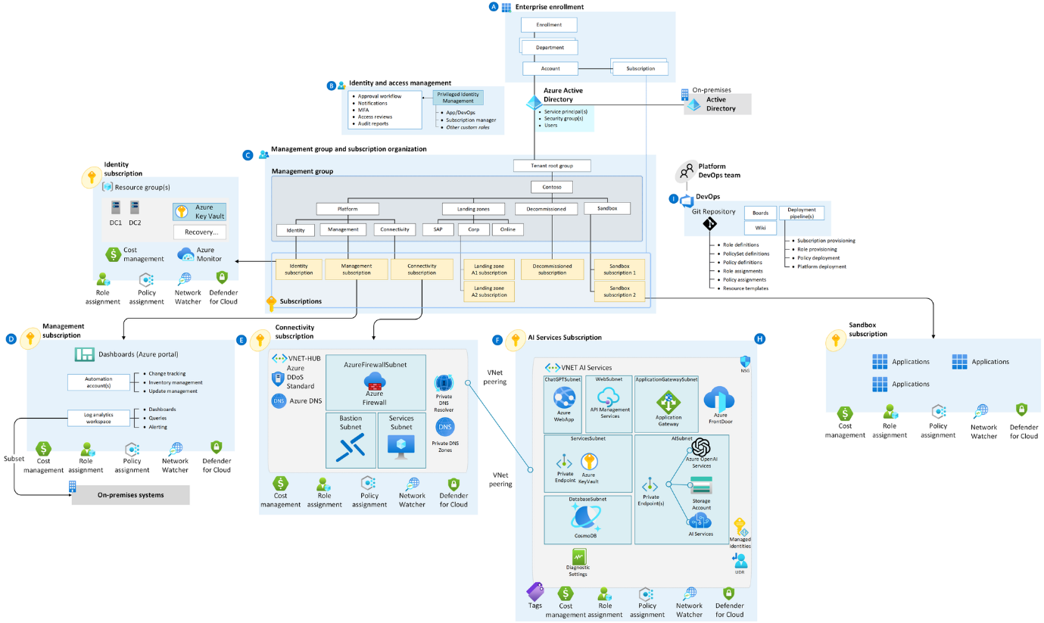

**Best Practices:** Policy-driven, sandbox for testing, cost tagging.

**Security & Governance:** MFA, RBAC, Defender for Cloud.

**References:** techcommunity.microsoft.com/blog/azurearchitectureblog/architecting-an-azure-ai-hub-and-spoke-landing-zone.

### 6. Generative AI Gateway Framework
**Framework ID:** COE-CAI-FW-006-GENAI-GATEWAY
**Version:** 1.0

**Overview & Value:** Centralized proxy for routing, governance, and cost control across models.

**Key Components:** Azure API Management, Azure OpenAI, Entra ID, Azure Monitor.

**Architecture Summary:** Requests → APIM policies → Route to backend → Logging/quotas.

**Best Practices:** Token limits, caching, audit trails.

**Security & Governance:** JWT, content filters.

**References:** learn.microsoft.com/en-us/ai/playbook/solutions/genai-gateway.

### 7. MLOps Framework for Azure Machine Learning
**Framework ID:** COE-CAI-FW-007-MLOPS
**Version:** 1.0

**Overview & Value:** Automated lifecycle for training, deployment, and monitoring of ML models.

**Key Components:** Azure ML, Azure DevOps/GitHub Actions, AKS/ACI endpoints.

**Architecture Summary:** Data → Training → Registry → Endpoint → Monitoring/drift.

**Best Practices:** MLflow tracking, CI/CD, automated retraining.

**Security & Governance:** VNet injection, managed identities.

**References:** learn.microsoft.com/en-us/azure/machine-learning/concept-azure-machine-learning-architecture.

### 8. Responsible AI Governance Framework
**Framework ID:** COE-CAI-FW-008-RESPONSIBLE-AI
**Version:** 1.0

**Overview & Value:** Ensures fairness, transparency, and accountability in AI deployments.

**Key Components:** Azure AI Content Safety, Responsible AI Dashboard, Azure ML interpretability.

**Architecture Summary:** Integrate filters → Assess impact → Monitor → Report.

**Best Practices:** Red teaming, bias checks, human oversight.

**Security & Governance:** Alignment with Microsoft Responsible AI Standard.

**References:** learn.microsoft.com/en-us/ai/playbook/responsible-ai.

### 9. Vector Search & Embedding Framework
**Framework ID:** COE-CAI-FW-009-VECTOR-SEARCH
**Version:** 1.0

**Overview & Value:** Core for semantic search in GenAI apps.

**Key Components:** Azure AI Search (vector), Azure OpenAI embeddings.

**Architecture Summary:** Ingest/embed → Index → Query/retrieve → Rerank.

**Best Practices:** Hybrid search, metadata filtering.

**Security & Governance:** Private endpoints, encryption.

**References:** learn.microsoft.com/en-us/azure/search/vector-search-overview.

### 10. AI Application Monitoring & Governance Framework
**Framework ID:** COE-CAI-FW-010-MONITORING
**Version:** 1.0

**Overview & Value:** Observability for AI workloads (usage, latency, drift).

**Key Components:** Azure Monitor, Application Insights, Log Analytics.

**Architecture Summary:** Telemetry collection → Dashboards/alerts → Drift detection.

**Best Practices:** Custom metrics, alerting thresholds.

**Security & Governance:** Retention policies, compliance reporting.

**References:** learn.microsoft.com/en-us/azure/well-architected/ai/operational-excellence.

These frameworks are ready for live demo (screen-share repo with diagrams, templates, and links). They align with Microsoft’s GenAI patterns and can be expanded with code samples or industry adaptations.

If you'd like:
- Elaboration on any one (e.g., full step-by-step like the RAG playbook)
- More diagrams
- Templates in Word/PDF format
- Adaptation for other CoEs

Let me know your priority!

